Problem 1. Building an ER model for a hospital
A hospital has a lot of doctors. Doctor's information includes doctor code (identifier), doctor's name, date of employment, and specialty. The patients are admitted to the hospital through doctors. Patient information includes patient identification (identifier) and patient name. A patient admitted to the hospital by only one doctor. One doctor can take on many patients. Once admitted to the hospital, a patient will be treated by at least one doctor. A doctor may treat no one patient or treat multiple patients. Hospitals need to save details about each time a doctor treats a patient. Treatment details include: date of treatment, duration of treatment and results.
Entities:
- Doctor: doctor_code (primary key), doctor_name, doctor_dateOfEmployment, doctor_speciality
- Patient: patient_code (primary key), patient_name
- Treatment Detail: treatment_date, treatment_duration, treament_result
Relationship:
- Patient (admitted) Doctor: N – 1
- Patient (treated) Doctor: M – N
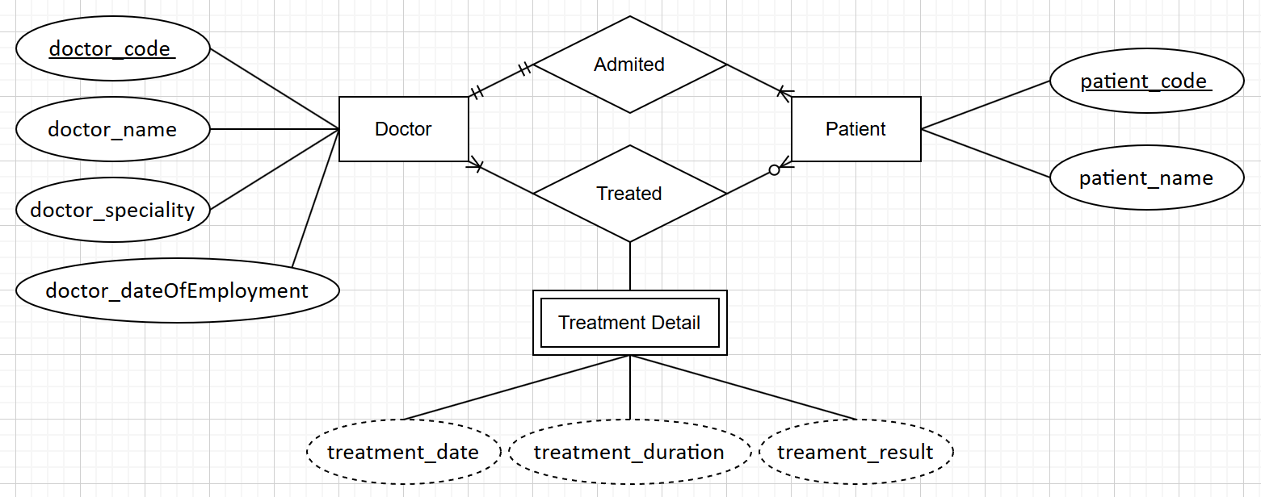
Problem 2. Building an ER model for a University A university needs to computerize its management.
The school has many faculties. Each faculty has information Faculty Code, Faculty Name. Each department has many classes. Class information: Class code, Class name, Wholesale number. A student upon admission is placed in a class. Student information includes: Student ID, Full name, Date of birth, gender, address. Students study a variety of subjects. At the end of each subject, students have one exam score. At the end of the course, students have a graduation point. Each subject has information: Subject code, Subject name, number of credits. Each student has a library card, and one library card belongs to only one student. Library card information: Card number, Issue date, Expiration date.
Entities:
- Faculty: faculty_code (primary key), faculty_name
- Class: class_code (primary key), class_name, class_number
- Student: student_code (primary key), student_fullname, student_dateOfBirth, student_gender, student_gender
- Subject: subject_code (primary key), subject_name, subject_credits
- Library Card: librarycard_code (primary key), librarycard_issueDate, librarycard_expirationDate
Relationship:
- Faculty (has) Class: 1 – N
- Student (placed) Class: N – 1
- Student (study) Subject: M – N
- Student (belong) Library Card: 1 – 1
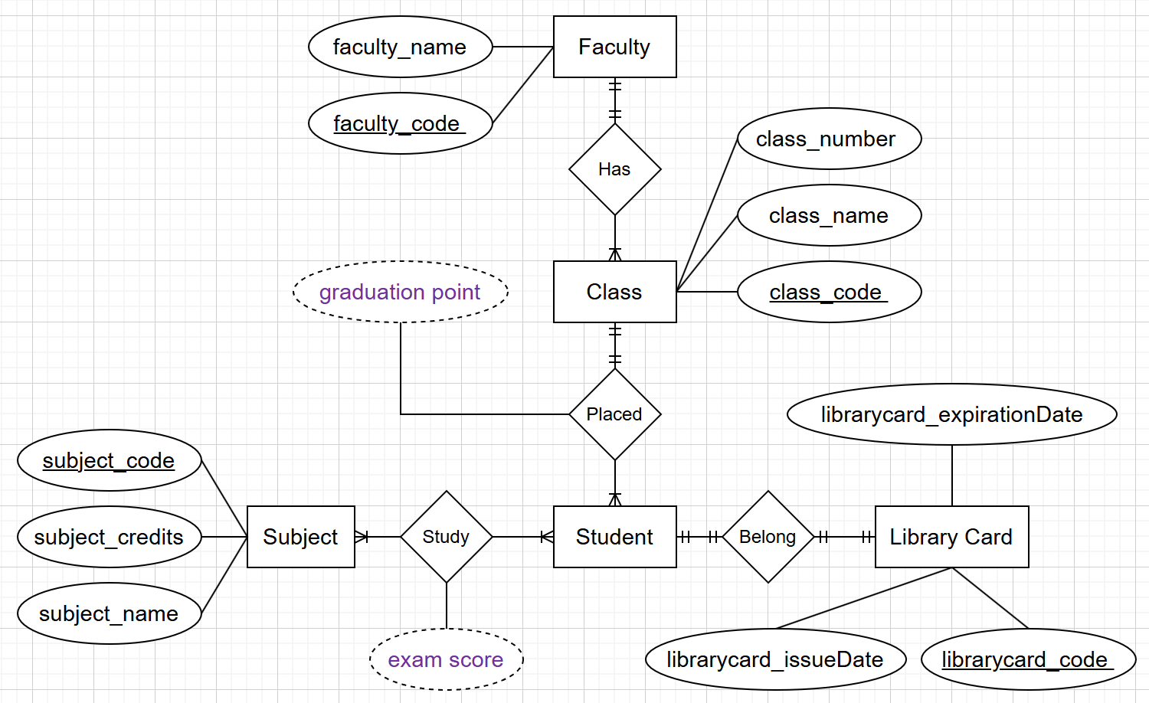
Problem 3. Building an ER model and relational data model for 1 hotel needs to store information as follows:
The hotel has many rooms, each room has room code (R101, R102, ...), room name (sunflower room, jade room, ....) Each room is located on 1 floor, floor information has floor code (F01, F02, ...), floor name (1st floor, 2nd floor, ...) Each room has a price corresponding to whether guests stay by week or by day. Each guest when arriving at the accommodation will have an identity card number, full name and corresponding phone number. There is also service information attached for each room: service code, service name and corresponding amount for each service when used 1 time. For example, service code: S01, service name is "Laundry", the amount is 50000.
Room payment invoice information for customers will have information: Invoice code, identity card code, full name of the customer, number of days of stay (arrival and departure dates), in which room, total amount to pay for the room. If guests stay for 1 week and 2 days, the week will be calculated according to the weekly unit price plus 2 odd days will be calculated according to the daily unit price. The invoice also stores information: service name and total service amount. The total amount of the guest to be paid (the sum of the total room amount and service fee).
Entities:
- Room: room_code (primary key), room_name, room_priceByWeek, room_priceByDay
- Floor: floor_code (primary key), floor_name
- Guest: guest_code (primary key), guest_fullname, guest_phoneNumber
- Service: service_code (primary key), service_name, service_amount
- Payment Invoice: invoice_code (primary key), invoice_arrivalDate, invoice_departureDate, invoice_totalPayment, room_code, guest_code.
- Detail Invoice: service_name, total_service_amount
Relationships:
- Room (located) Floor: N – 1
- Guest (pay) Payment Invoice: 1 – N
- Room (choose) Payment Invoice: 1 – N
- Payment Invoice (has) Detail Invoice: 1 – N
- Detail Invoice (belong) Service: N – 1
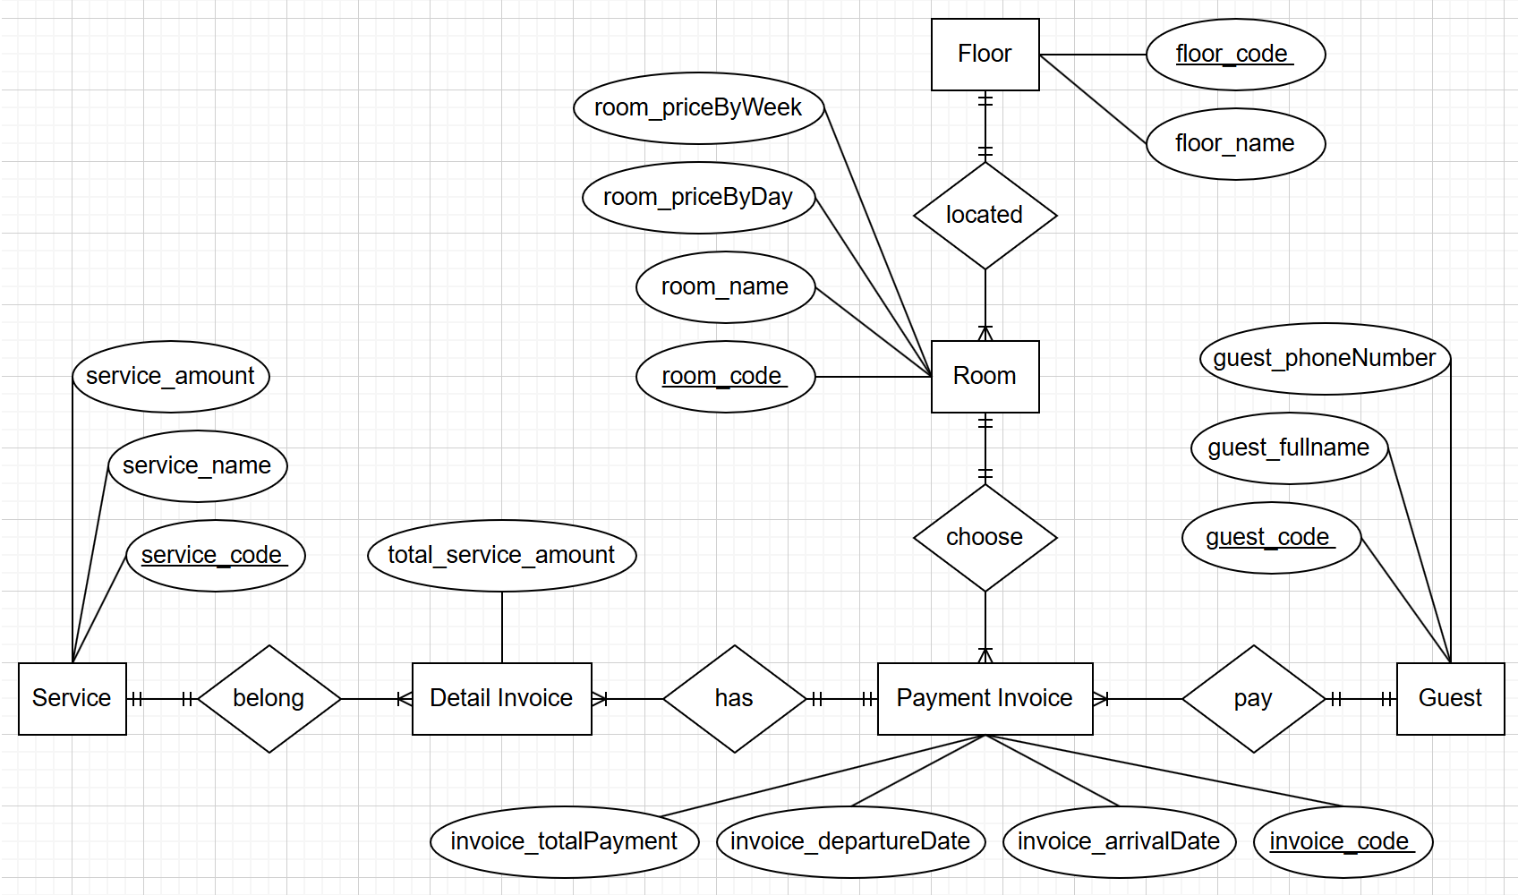
Problem 4. Building an ER model from Database Schema
CUSTOMERS (CUSTOMERID, FULLNAME, ADDRESS, PHONE, BIRTHDAY, SALE, REGISTRATIONDATE)
New word: Customer relationship will store information of member customers including attributes: customer ID, full name, address, phone number, date of birth, registration date and sales (total value of invoices of this member customer).
STAFF (STAFFID, FULLNAME, DAYOFENTRY, PHONE)
New words: Each salesperson needs to write down their full name, date of entry, contact phone, each employee distinguishes each other by employee code.
PRODUCTS (PRODUCTID, PRODUCTNAME, UNIT, NATION, PRICE)
New words: Each product has a code, an appellation, unit, country of manufacture and a selling price.
INVOICE (INVOICEID, PURCHASEDATE, CUSTOMERID, STAFFID, VALUE)
New words: When purchasing, each customer will receive a bill, which will contain the invoice number, the date of purchase, which employee sells, how much the invoice is worth and the customer's number if a member customer.
DETAILOFINVOICE (INVOICEID, PRODUCTID, QUANTITY)
New words: Explain in detail what products are included in each invoice and in what quantity.
Relationships:
- Customer (pay) Invoice: 1 – N
- Invoice (issue) Staff: N – 1
- Invoice (contain) Detail of Invoice: 1 – N
- Detail of Invoice (belong) Product: N – 1

